2022 VCE VET Furnishing external assessment report

General comments

Student responses to the exam were generally sound and thoughtful.

Area of strength were:

* work health and safety (WHS)
* identification of tools/equipment
* knowledge of joints.

The 2022 examination covered key knowledge and skills from the four units of competency:

* MSFFM2001 Use furniture making sector hand and power tools
* Questions relating to this unit were well answered. Students had a good knowledge of tools they had used but their knowledge did not extend to the full range described in the unit of competence. Knowledge of both hand and power tools was similar.
* MSFFM2002 Assemble furnishing components
* Assembly process questions continue to be a challenge for students. Responses showed familiarity with only a narrow range of furniture assembly methods and hardware.
* MSFFP2001 Undertake a basic furniture making project
* This unit addressed a wide range of skills and knowledge necessary to successfully plan and manufacture a basic furniture project. Good knowledge of the manufacturing process was evident. Questions relating to planning processes posed a challenge for some students.
* MSFGN2001 Make measurements and calculations
* Questions relating to the calculations part of the unit were generally well answered. Accurate use of measurement tools is an area for improvement

Responses to questions about safely operating tools and equipment were well answered. Understanding how to set up tools and planning for manufacturing operations posed a major challenge for some students.

Knowledge of a broader range of products, processes and methods were needed for higher-scoring responses. Production planning, completing cutting lists and optimisation plans were areas that could benefit from additional learning.

Specific information

This report provides sample answers or an indication of what answers may have included. Unless otherwise stated, these are not intended to be exemplary or complete responses.

The statistics in this report may be subject to rounding resulting in a total more or less than 100 per cent.

Section A

|  |  |  |  |  |  |  |
| --- | --- | --- | --- | --- | --- | --- |
| Question | Correct answer | % A | % B | % C | % D | Comments |
| 1 | C | 4 | 4 | **55** | 38 | A fine pencil line is used. |
| 2 | A | **67** | 2 | 15 | 16 |  |
| 3 | B | 11 | **67** | 11 | 11 |  |
| 4 | B | 9 | **76** | 4 | 11 |  |
| 5 | D | 0 | 4 | 7 | **89** |  |
| 6 | B | 13 | **64** | 7 | 16 |  |
| 7 | C | 4 | 2 | **51** | 42 |  |
| 8 | C | 9 | 0 | **91** | 0 |  |
| 9 | C | 73 | 4 | **24** | 0 | Many students were not familiar with reading a Vernier scale. |
| 10 | C | 13 | 15 | **73** | 0 |  |
| 11 | B | 13 | **55** | 29 | 4 | Countersinking slightly below the surface will prevent the draw side wearing prematurely. |
| 12 | D | 33 | 5 | 0 | **62** | A sliding bevel is necessary to mark the angles. |
| 13 | B | 9 | **64** | 15 | 13 |  |
| 14 | D | 15 | 11 | 11 | **64** |  |
| 15 | C | 20 | 29 | **35** | 16 | = 8  8(2700 + 20) = 21.76 m |
| 16 | C | 18 | 9 | 65 | 7 |  |
| 17 | D | 16 | 9 | 0 | **75** |  |
| 18 | B | 24 | **47** | 25 | 4 |  |
| 19 | A | **42** | 31 | 11 | 16 | Tenon: Haunch = 5 : 4 |
| 20 | A | **31** | 16 | 38 | 15 | Use the longest plane possible to ensure a straight joint. |

Section B

Question 1

|  |  |  |  |  |  |  |  |
| --- | --- | --- | --- | --- | --- | --- | --- |
| Mark | 0 | 1 | 2 | 3 | 4 | 5 | Average |
| % | 7 | 18 | 20 | 27 | 16 | 12 | 2.6 |

|  |  |  |
| --- | --- | --- |
| Hand tool | Name of hand tool | What the hand tools is used for |
| A | Claw hammer | General nailing and removing nails |
| B | Mortice gauge | Marking mortice and other joints |
| C | Tennon or dovetail saw / Book saw | Cutting joints |
| D | Mallet | Driving chisels |
| E | Sliding bevel | Transferring and marking angles |

Question 2a.

|  |  |  |  |
| --- | --- | --- | --- |
| Mark | 0 | 1 | Average |
| % | 88 | 12 | 0.11 |

The arris is the sharp edges on timber formed where and two faces meet.

Question 2b.

|  |  |  |  |
| --- | --- | --- | --- |
| Mark | 0 | 1 | Average |
| % | 70 | 30 | 0.3 |

Arris is removed by using abrasive (sand) paper supported by a sanding block or use a block plane.

Question 3a.

|  |  |  |  |  |
| --- | --- | --- | --- | --- |
| Mark | 0 | 1 | 2 | Average |
| % | 92 | 3 | 6 | 0.14 |

Question 3b.

|  |  |  |  |  |  |  |  |  |
| --- | --- | --- | --- | --- | --- | --- | --- | --- |
| Mark | 0 | 1 | 2 | 3 | 4 | 5 | 6 | Average |
| % | 12 | 12 | 25 | 19 | 8 | 16 | 9 | 2.8 |

|  |  |  |  |  |  |  |
| --- | --- | --- | --- | --- | --- | --- |
|  | **Glue No. 1** | | | | | **Glue No. 2** |
| **Name of glue** | Polyurethane | Cont act | hide | PVA | Super | Epoxy |
| **Advantage** | Premixed |  |  | Premixed |  | Strong |
|  | Strong Waterproof Gap filling  Rapid setting | Easy to use Low cost | Waterproof Gap filling  Variable drying time |
| **Disadvantage** | Toxic  Hard to clean up Expensive Requires PPE |  |  | Not waterproof Longer drying time |  | Cost  Must be mixed. Hard to clean up  Requires PPE |

Contact, hide and super glues are not suitable for widening joints in tabletops.

Question 4

|  |  |  |  |  |  |  |  |  |  |
| --- | --- | --- | --- | --- | --- | --- | --- | --- | --- |
| Mark | 0 | 1 | 2 | 3 | 4 | 5 | 6 | 7 | Average |
| % | 34 | 19 | 4 | 9 | 2 | 10 | 23 | 34 | 2.5 |

|  |  |  |  |  |  |  |
| --- | --- | --- | --- | --- | --- | --- |
| **Mark** | **0** | **1** | **2** | **3** | **4** | **Average** |
| **%** | **2** | **17** | **36** | **35** | **10** | **2.3** |
| **Item No.** | **Item** | **Qty** | **Length (mm)** | **Width (mm)** | **Thickness (mm)** | **Amount of timber required (m3)** |
| 1 | Leg | 4 | 765 | 40 | 40 | 0.004896 |
| 2 | Rails | 4 | 425 | 100 | 19 | 0.003230 |
| 3 | Top | 1 | 545 | 545 | 19 | 0.005643 |
| Total for one table (m3) | | | | | | 0.013769 |
| 25% waste (m3) | | | | | | 0.003442 |
| Total including waste for one table (m3) | | | | | | 0.017211 |
| Total for 70 tables (m3) | | | | | | 1.204788 or 1.2 |

Question 5

|  |  |  |  |  |
| --- | --- | --- | --- | --- |
| Mark | 0 | 1 | 2 | Average |
| % | 56 | 0 | 44 | 2.3 |

Students were required to show saw end grain and correct orientation.

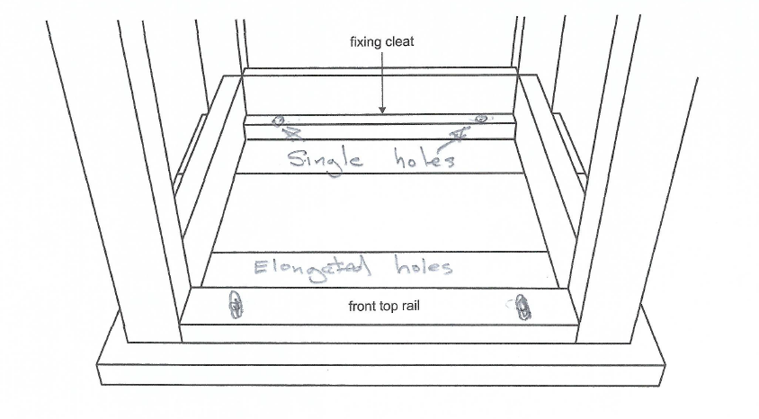Question 6

|  |  |  |  |  |
| --- | --- | --- | --- | --- |
| Mark | 0 | 1 | 2 | Average |
| % | 51 | 41 | 7 | 0.6 |

Question 7

|  |  |  |  |  |
| --- | --- | --- | --- | --- |
| Mark | 0 | 1 | 2 | Average |
| % | 62 | 29 | 9 | 0.5 |

* The dowels should be inserted into the leg first. Insert in shallowest hole first.
* The hole in the leg is the shallower of the two. You should always put the dowel in the shallower hole for maximum fixing strength.

Question 8

|  |  |  |  |  |  |  |  |  |
| --- | --- | --- | --- | --- | --- | --- | --- | --- |
| Mark | 0 | 1 | 2 | 3 | 4 | 5 | 6 | Average |
| % | 13 | 17 | 32 | 15 | 7 | 5 | 11 | 2.5 |

* Figure 8: used for joining adjacent components; fixing tops, fixing panels
* Shelf support: used for adjustable shelves
* L / right angle / 90-degree bracket: used for fixing cabinets, fixing tops, perpendicular parts.

Question 9

|  |  |  |  |  |
| --- | --- | --- | --- | --- |
| Mark | 0 | 1 | 2 | Average |
| % | 14 | 47 | 39 | 1.3 |

* Use team lifting.
* Use lifting aids / trolley.
* Use correct lifting techniques.

Question 10

|  |  |  |  |  |  |  |
| --- | --- | --- | --- | --- | --- | --- |
| Mark | 0 | 1 | 2 | 3 | 4 | Average |
| % | 6 | 13 | 26 | 0 | 56 | 2.89 |

Section C – Case study

Question 1

|  |  |  |  |  |  |  |  |
| --- | --- | --- | --- | --- | --- | --- | --- |
| Mark | 0 | 1 | 2 | 3 | 4 | 5 | Average |
| % | 9 | 10 | 20 | 28 | 18 | 15 | 2.8 |

|  |  |
| --- | --- |
| **Task** | **Purpose** |
| Develop the design brief. | Record of client requirements, consideration constraints/parameters/specifications. |
| Produce the working drawings. | Detail the sizes and construction of the job. Communicate to the client and other workers. |
| Prepare the cutting list and optimising plan. | Work out the best use of materials and record the sizes of parts for own work and communication with other trades. |
| Calculate the material costing and quote. | Calculate cost and ensure a profit.  Communicate with the client and ensure agreement. |
| Write the project work plan | Plan the construction sequence, tool and equipment requirements and timeframes.  Plan for dependencies and contingencies. |

Question 2

|  |  |  |  |  |  |  |  |  |
| --- | --- | --- | --- | --- | --- | --- | --- | --- |
| Mark | 0 | 1 | 2 | 3 | 4 | 5 | 6 | Average |
| % | 13 | 13 | 19 | 29 | 16 | 11 | 0 | 2.8 |

The missing information is set out in the following table.

|  |  |
| --- | --- |
| bottom rail thickness | 40mm |
| splat width | 125mm |
| front/back top rails length | 1300mm |
| front and back panels | 20mm |
| base materials | wide grain, bamboo and plywood |
| seat thickness | 19mm |

Question 3

|  |  |  |  |  |  |  |  |
| --- | --- | --- | --- | --- | --- | --- | --- |
| Mark | 0 | 1 | 2 | 3 | 4 | 5 | Average |
| % | 6 | 6 | 4 | 11 | 2 | 73 | 4.2 |

|  |  |  |
| --- | --- | --- |
| **Project work plan for the backrest** | | |
| **Step** | **tools/equipment required** | **Personal protective equipment (PPE) for task** |
| Machine timber and cut to length | **3 drop saw, jointer, thicknesser** | eye, hearing protection.  Protective clothing. Foot protection. |
| Make router templates for the top rail, stiles, centre back splat. | pencil, 1000mm ruler, jig saw, spokeshave | protective clothing. foot protection. |
| Mark out top rail, stiles, centre back splat using templates | pencil, templates | protective clothing. foot protection. |
| Mark out all dowel joints | pencil, 150mm ruler, marking gauge, square. | protective clothing. foot protection. |
| **1 Drill dowel joints** | battery drill, dowel jig, | eye, hearing, foot protection. protective clothing. |
| Cut back top rail, stiles, and splat roughly to size | **4. jigsaw** | eye, hearing, foot protection. protective clothing |
| Screw fix templates to shaped components | impact driver | protective clothing. foot protection. |
| Rout top back rail, sides and splat to shape with a flush cutter. | router with flush cutter, extractor | eye, hearing, foot protection. protective clothing |
| Use a rebate cutter to rout out the groove for thesplat/slats | router with rebate cutter, extractor | eye, hearing protection, foot. protective clothing |
| Fit block between slats and splats in top and bottom rail | glue, hammer and brads | protective clothing, foot protection. |
| Sand all parts | orbital sander, sanding block shaped sanding blocks, abrasive paper | eye, hearing, foot protection. protective clothing |
| **5 dry clamp to check if components fit together** | sash clamps, top rail clamping jig, blocks, glue, rags, ruler or straight edge, tape measure | protective clothing, foot protection. |
| Glue top and bottom rails to back slats and check for square, twist/wind | sash clamps, top rail clamping jig, blocks, glue, rags, ruler or straight edge, tape measure | protective clothing, gloves, foot protection. |
| Glue back frame to sides/stiles -check for square, twist/wind | **2 sash clamps, top rail clamping jig, blocks, glue, rags, ruler or straight edge, tape measure** | protective clothing, gloves, foot protection. |

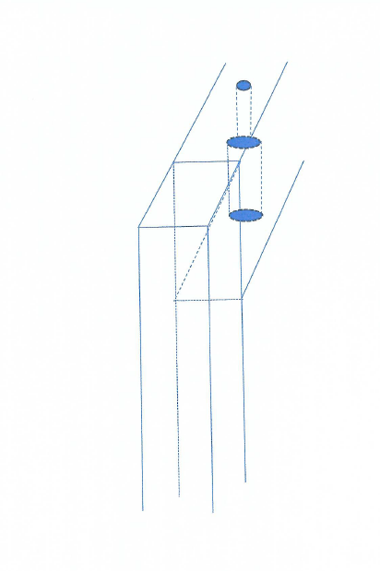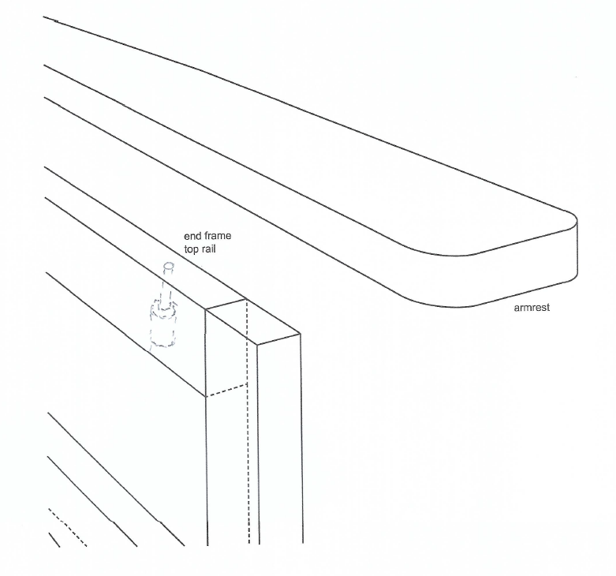Question 4

|  |  |  |  |  |
| --- | --- | --- | --- | --- |
| Mark | 0 | 1 | 2 | Average |
| % | 55 | 42 | 3.7 | 0.5 |

Question 5

|  |  |  |  |  |  |  |
| --- | --- | --- | --- | --- | --- | --- |
| Mark | 0 | 1 | 2 | 3 | 4 | Average |
| % | 41 | 24 | 26 | 0 | 9 | 1.2 |

Question 6

|  |  |  |  |  |  |  |  |  |
| --- | --- | --- | --- | --- | --- | --- | --- | --- |
| Mark | 0 | 1 | 2 | 3 | 4 | 5 | 6 | Average |
| % | 67 | 4 | 16 | 1 | 11 | 0 | 0 | 0.8 |

|  |  |  |
| --- | --- | --- |
| Step 2 | Measure the length of hinge (100mm), and then mark this inward from the first mark (length of hinge). | Ruler/tape measure/square/marking gauge |
| Step 4 | Now set the marking gauge to the width of the hinge - from the outside of the leaf to the center of the knuckle. Run the gauge along the top edge - in between the squared lines, from the outside faces. | Ruler/tape measure/square/marking gauge |
| Step 5 | Carefully cut out the inside ends of where the hinges fit, using a sharp beveled edge chisel and/or small hand saw, then the remaining recess. Be sure to work to the marked lines. Check the edges, ends and depth/width of cut. Dry fit hinges. The knuckle should stick out halfway, on the outside faces. | Marking knife/Stanley knife/ chisel/ mallet/ trimmer PPE |

Question 7

|  |  |  |  |  |  |  |
| --- | --- | --- | --- | --- | --- | --- |
| Mark | 0 | 1 | 2 | 3 | 4 | Average |
| % | 15 | 20 | 35 | 20 | 11 | 1.9 |

Any of four of the following tasks:

* Arise all edges, i.e. no sharp edges
* Remove visible marks (machine, pencil, glue, clamp, power tool)
* Remove all visible scratches and/or cross grain sanding marks
* Remove or fill blemishes and dents
* Remove all hardware prior to oiling
* Remove dust/sawdust
* Sand.

Question 8

|  |  |  |  |  |
| --- | --- | --- | --- | --- |
| Mark | 0 | 1 | 2 | Average |
| % | 19 | 42 | 39 | 1.2 |

Both of the following:

* Stop using / remove from workplace
* Tag and report in accordance with workplace procedures

Question 9a.

|  |  |  |  |
| --- | --- | --- | --- |
| Mark | 0 | 1 | Average |
| % | 96 | 4 | 0.03 |

30mm

Question 9b.

|  |  |  |  |
| --- | --- | --- | --- |
| Mark | 0 | 1 | Average |
| % | 69 | 31 | 0.3 |

Change the bearing to a different diameter bearing.

Question 10

|  |  |  |  |
| --- | --- | --- | --- |
| Mark | 0 | 1 | Average |
| % | 98 | 2 | 0.01 |

Tenon saw/ coping saw / jigsaw

Question 11

|  |  |  |  |
| --- | --- | --- | --- |
| Mark | 0 | 1 | Average |
| % | 96 | 4 | 2.3 |

Question 12

|  |  |  |  |
| --- | --- | --- | --- |
| Mark | 0 | 1 | Average |
| % | 96 | 4 | 0.03 |

* Place the screws in the area covered by the rail joints
* Extend the template beyond the ends of the completed leg to allow for screw mounting

Question 13

|  |  |  |  |
| --- | --- | --- | --- |
| Mark | 0 | 1 | Average |
| % | 47 | 53 | 0.52 |

* Ensure accurate centre marks by using a sharp pencil, by using marking tool, transfer marks from the set­ out or plans double check marking.
* Make a jig or template for marking out.
* Give marks for either accuracy and/or minimising errors.